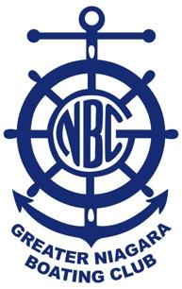
The Greater Niagara Boating Club

2025 Clubhouse Membership Application

PLEASE PRINT CLEARLY

Name:
Address:
City/Prov: |  |  | Postal Code:
Email:
Phone: | Cell Phone:
Please Circle: |  | New Renewal | Sponsor:
Date: |  | Signature:

Membership entitles payee to use of Clubhouse services and invitations to GNBC events

Annual Membership Fee:$35.00(incl HST)

The Membership fee is due annually. Membership expires at the end of the month, one year from the date of purchase.

As a condition of membership, the member hereby agrees and covenants to hold harmless, GNBC, its Board of Directors and Employees, for whom the GNBC may, in law, be responsible, whether or not any loss or damage is caused by any act, omission or negligence of The Greater Niagara Boating Club.

Membership includes the member’s spouse/significant other and dependent children under the age of 18, as well as children under the age of 22 who are full time students or dependent children as defined as a legal dependent by the Succession Law Reform Act.

Email is the only method of communication used. Please keep us up to date on email address changes as well as phone or address changes.

Office Use Only

Date Received | Method of Payment | Expiry Date | Added to Contact List

